Introduction

Problem Statement
Walkers Tours is the one of the leading company in the destination management industry in Sri Lanka. The principal activity of walkers’ tours is focusing on In-Bound Tourism and providing destination management services. Together with its brands which are well equipped to serve destination management requirements of all travelers. Destination Management System (DMS) for Walkers Tours Limited (WTL) is intended to manage client (Tourist) information such as registration details, tour details (Places, Hotels, Food and Accommodation) and payment details in an effective and efficient way within the company.

There are number of operations that are to be supported through the proposed system. Some of them are calculate the charges, update the new changes, keep track of the traveler’s details. Currently most of these are being done as paper based system and if it is going to be as it is, it will not suitable to the new technology. Hence the users see the needs for change.

The other problem which was brought to our attention was, a new traveler can select only the wanted tour-package such as Cultural triangle, Southern coastal, Hill country, classical visit, etc from our client. In some situation traveler, want to visit only particular places not according to the package. In this situation there is no such service provide by our client right now.

Our solution for this problems are automate their day-to-day functions by a standalone system, and a website with more features such as can easily keep track of the details of customers and packages through our proposed system.

To make their existing website more user friendly, we decided to introduce, select the visiting places by clicking system that is travelers can select the particular places which they want to visit by clicking not according to the package wised always.

Our other introducing feature is display the amount of a tour with tourist’s all needs after they registered, this is more helpful to tourist to take the decision of their tourist expenses. Also we are going to introduce the mileage calculation feature. That is we are going to calculate the travelling charges according the miles they travel not just package.

The reports that could be generated by the system are time schedules such as traveler’s details, reminders about upcoming celebration details, special offers details and other tourist reminders. Our system will send this generated mail to the tourist as reminders automatically. Hence satisfying all the requirements specified the project is going towards the goal of developing a reliable and easy to use tool for the DMS. All the interfaces are designed considering the user friendly factor in mind.

The vision of our project is to provide our client WTL with an accurate and efficient system to solve the existing problem domain.

Product Scope
We describe the functions within the scope of the proposed system. This system supposed to manage client (Tourist) information such as registration details, tour details (Places, Hotels, Food and Accommodation) and payment details.

Benefits of this DMS
- Improved management information
- Faster processing of staffs and services details
- More accurate tourist details and information
- The new system is going to radically change the way the Walkers Tours administration, services.

Objectives of this DMS
- Ease and reduce the work load of the end users.
    - Increase the reliability and efficiency of the work process.
    - Provide more capabilities in order to fulfill user requirements up to the maximum level.
    - Increase user friendliness towards the system.
    - Interoperability of the system.

Goals of our project
- Give an immediate response.
- Maintain documents, various action which involved with DMS.

Project Report Structure
This document will have a standard format of our final report. In this report we are explain our system in four main parts as Introduction, Methodology Evaluation and Conclusion.
- In Introduction we are describing about the problem statement, and product scope.
  - Problem statement – Explain about the case for the need of this project. Also include a detailed specification (problem statement) of the project.
  - Product scope – Provide a short description of our software being specified and its purpose, including relevant benefits, objectives, and goals. Relate the software to corporate goals or business strategies. Also describe the Basic findings of the project in summarized form.
- In Methodology we are describing about requirements and analysis, design, implementation, testing phases of our system.
- Requirements and analysis - Explain about specific requirements of our project included with use case and activity diagrams.
- Design - Explain about the design of the software using UML diagrams such as Deployment diagram, component diagram, class diagram, Sequence diagram, State Charts. And explain the database design using the ER diagrams to Logical model Database schema.
- Implementation – Explain about major module structures of our project. And some reusable code. Also explain the choice of DBMS, Implementation Languages.
- Design – Explain about our test plan.
  - In Evaluation we are describing about Assessment of the project results, lesson learned and future work of our system.
  - In conclusion we are describing sums up the whole project. Discuss the realization of the original objectives/goals and how work can be taken further.

Methodology

Requirements and Analysis
We planed the basic templates of our system ^{[1]} and decided to go through the Software life cycle phases.

- First we analysis of the problem.
- Collect the data which would be the system.
- Disused about the processing required to be carried out on these data.
- Got to know about the output data required to be produced by the system.
- As well as we study of various constraints on the behavior of the system.

Finally we analyzed to arrive at an abstract definition of the problem and different solution strategies. Examined of alternative solution strategies and their benefits ^{[4]}, indicating resources required, development cost and time. We determined which solution is the best. So for running the project and the organization successfully this step is a very important step in a development process.

We used Requirements Analysis phase to collect and analyze all related data and information with a view to understanding the WTL requirements clearly. We start this through interviews ^{[2]} and discussions with WTL staffs. We obtained a clear, in-depth understanding of the problem that is to be solved; already company has given some requirements such as
- Create the website more users friendly.
- Traveler can select their visiting places as their own, not according to the packages.
- Ability to view travel cost by traveler when they select their needs.
- Ability to view the tour plan by tourist after register with us.
- Tourist can pay the amount through our website online facility.
- Ability to change rates like mileage charges, vehicle charges etc.

One of the main modules in this system is ‘Online Reservation’. At this point client can get register through online to visit SriLanka. To develop the system gathering the requirements via the questionnaire was a major advantage that we had. The main requirements that were gathered are mentioned below.

Now WTL serving some readymade packages to their clients, compare this to the current situation in the same industry, they are allowing their clients to select their needs according to their wish and at the same time they are calculating the total cost according to tourist selection.

Following details on the clients should be tracked at the time of reservation through online. Tourist Name, Passport No, Country, Telephone No, E-mail address, No of person who is going to visit Sri Lanka and other tourist selection. It is assumed that seating capacity and weight are standard information so that kind of information is not tracked. Normally the company categorizing hotel room types as Single bed room, Double bed room and Triple bed room. To the meal types now they are categorizing as Bread & Breakfast, Half Board and Full Board. Same as in the Vehicles they are categorizing as Car, Luxury Car, Mini Coach and Coach.

Currently for each vehicle each driver is allocated and in addition to this if tourist need any guide, guide also allocated to the clients. But WTL having some language speaking tour guides with them but there is a way to give their services to client through online right new.

After tourist back from SriLanka new their is no way to keep track of their details or no contacts with them and right now it’s hard to get the annual feedbacks (Report or Graphs) to the Marketing officer.

Below we are describing the requirements what we got at analysis phase with WTL staff using use case diagram and activity diagram.

Use case Diagrams for WTL Requirements
This system gathers the client’s information and their selections of the tour. At that time after the online registration client will get a serial no and copy of all selection details, payment details will send to client’s mail it will done automatically. After all the selections are done by client according to the mileage calculation the total amount will be shown to the client, after that if he like to continue feather client will pay in online. The serial number is unique to the each and every client.

2.1.1.1 Use case for internal users

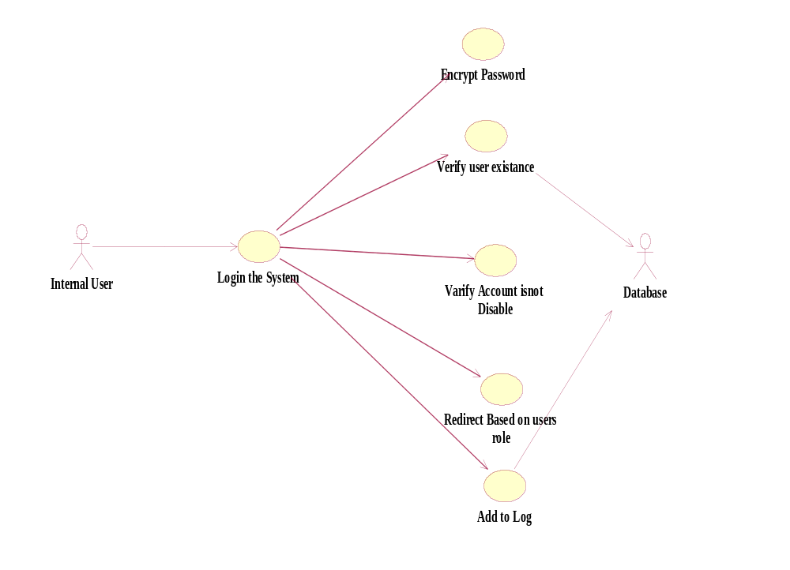
Figure -1-
2.1.1.2 Use case for Tourist 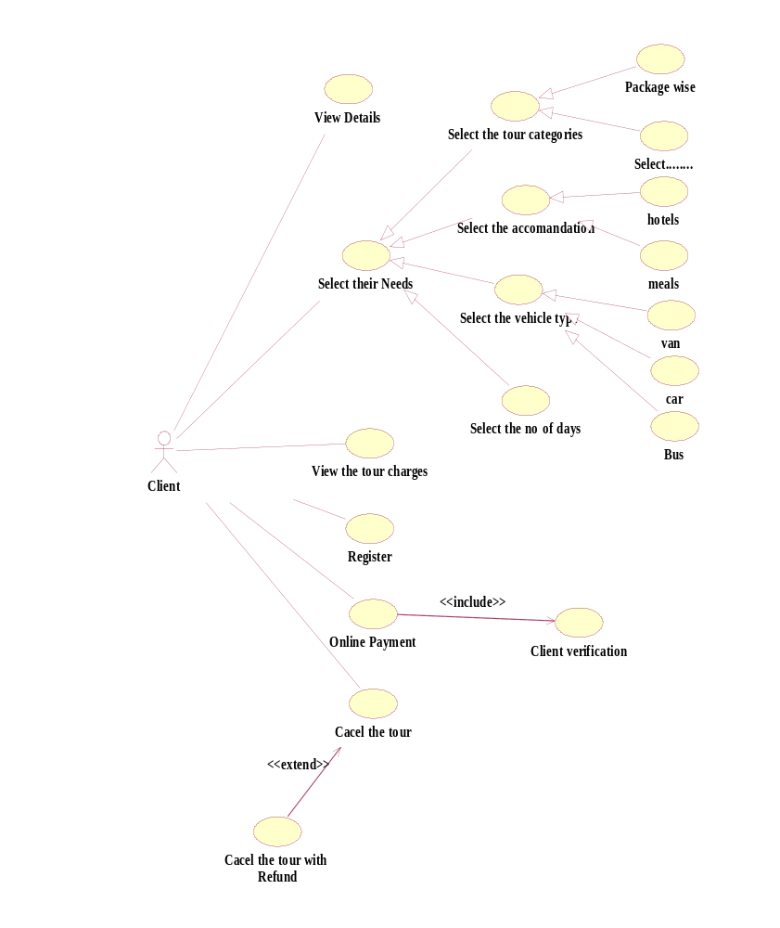

Figure -2-

2.1.1.3 Use case for Marketing Officer

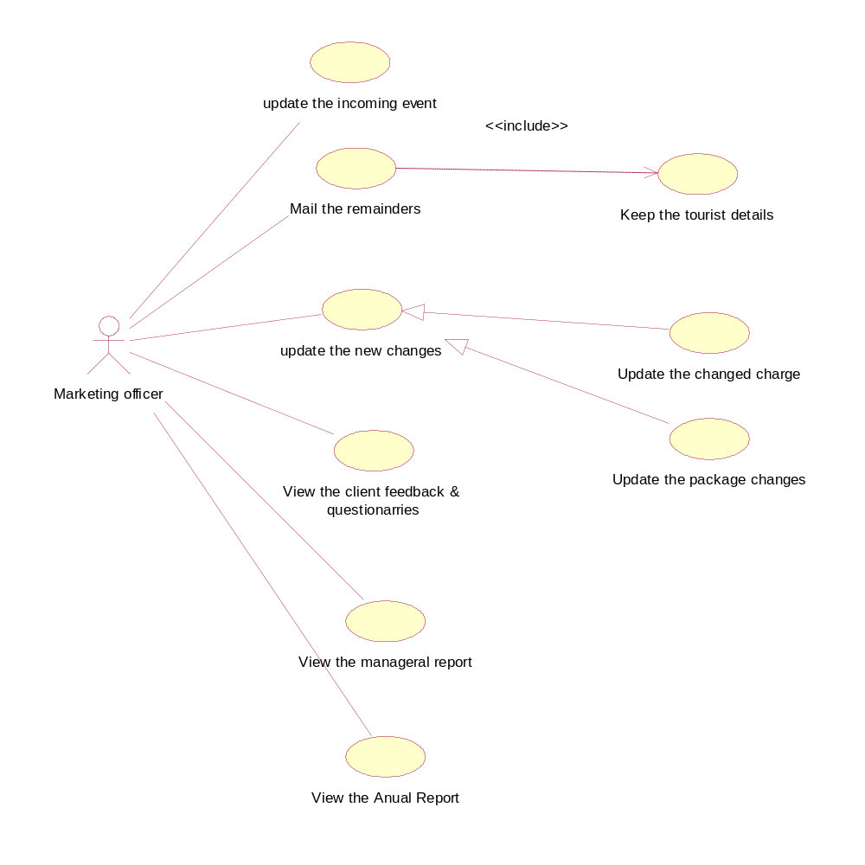

Figure -3-

2.1.1.4 Use case for Administrator

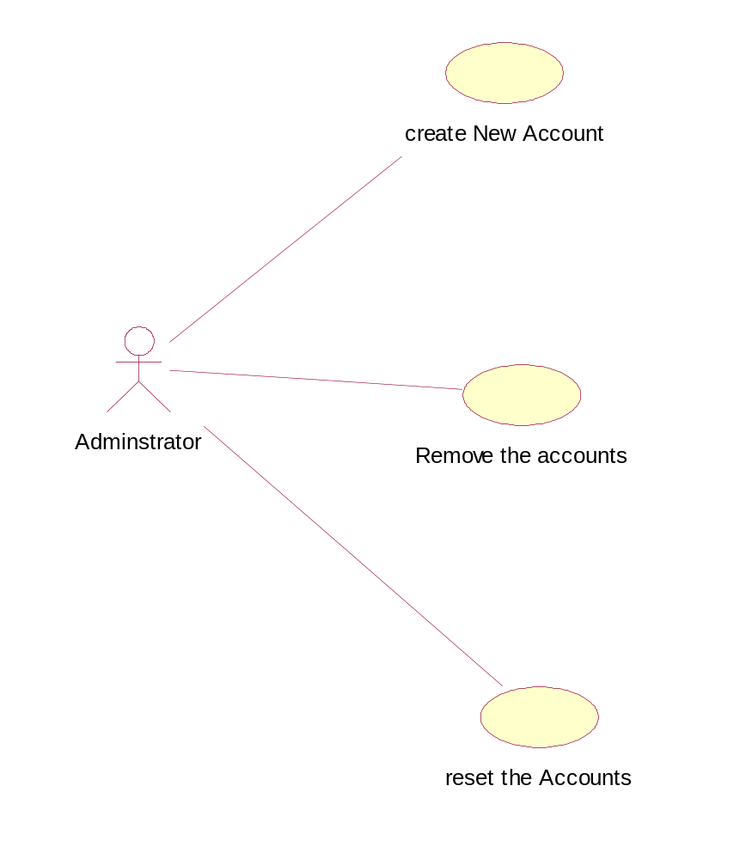

Figure -4-

Activity Diagrams for WTL Requirements

Activity Diagram for Client Registration

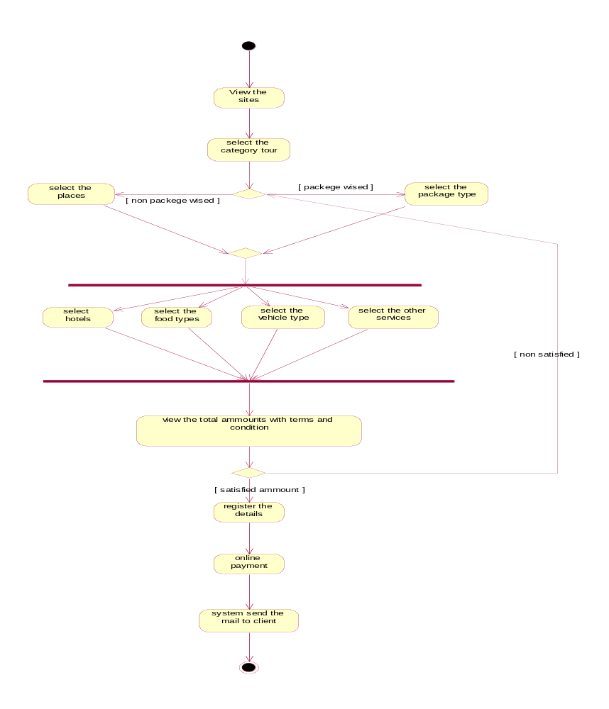

Figure -5-

Activity Diagram for WTLs’ Internal user’s Activities

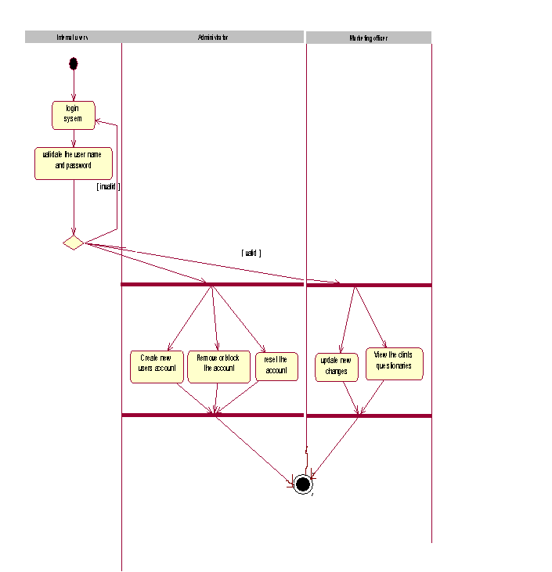

Figure -6-

Design
We transform the specification into a form suitable for implementation in a programming language. Object oriented development methodology is used to build up the system as it is a more effective way of developing flexible software. Components needed for a successful project are notation, process and tool. The proposed system makes use of UML which stands for Unified Modeling Language as the notation, Unified process as the process and Rational Rose as the tool.
Any software development method is best supported by a tool. The tool used for this project is Rational Rose and the reasons for using Rational Rose are as follows.

Rose facilitates object-oriented analysis and design. It allows analysts, engineers, writers, and project managers to create, view, manipulate, and modify elements in a Unified Modeling Language (UML) across the entire enterprise, using one tool and one language. The tool’s true value is that it exposes software development problems early on in the development life cycle, helping you manage everything from straightforward projects to more complex software solutions. Basically, Rose supports use-case-driven object modeling.

First we identified the various objects that occur in the problem domain and the solution domain and the different kinds relationships that exist among these objects. This system is built so as to overcome the matters which were identified during the requirement gathering.

Below our deigned UML diagrams for our system DMS.

Class Diagram

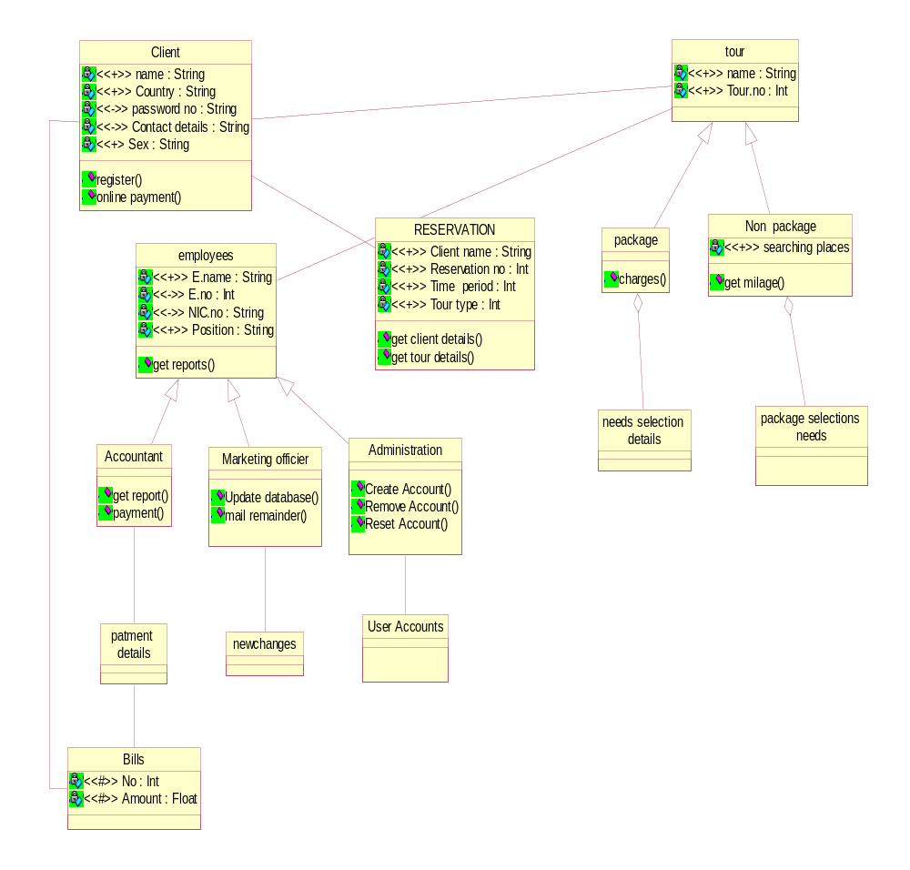

Figure -7-

Sequence Diagram

Sequence diagram for tourist Rerservation

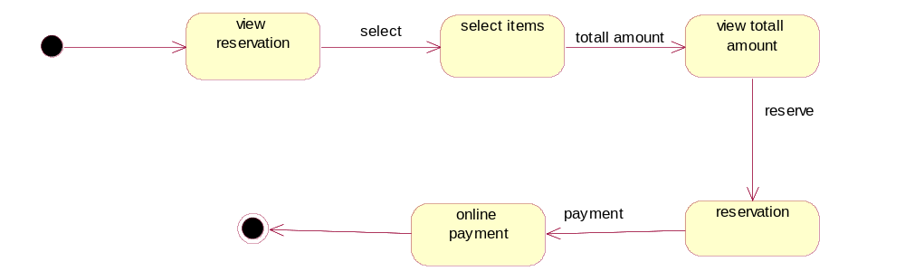

Figure -8-

2.2.2.2 Sequence diagram for marketing Officer

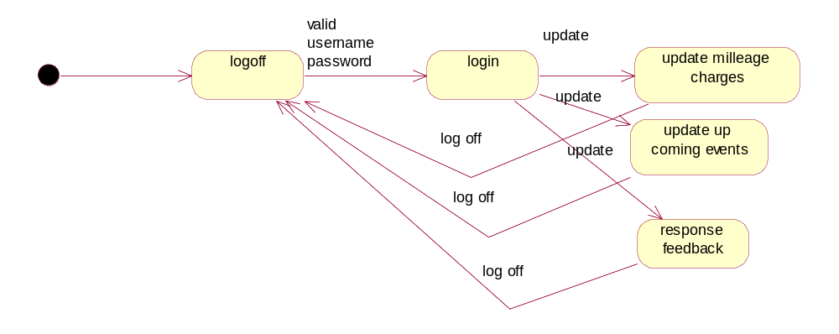

Figure -9-

2.2.2.3 Sequence diagram for administrator

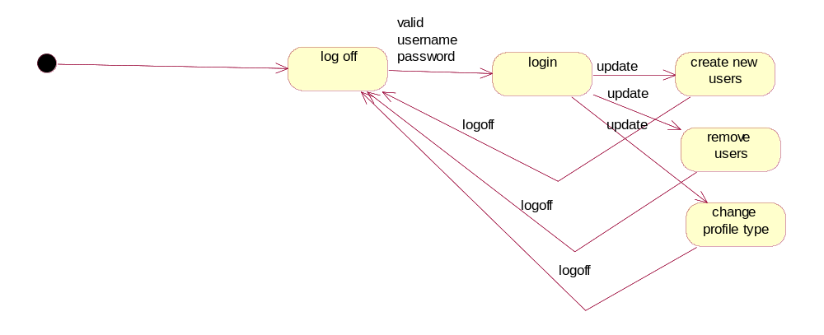
Figure -10-

Database Design

Database is a repository for a collection of computerized data files. The users of the system perform a variety of operations on such files.
- Adding or removing files to the database
- Inserting new data into existing files
- Retrieving (deleting/updating) data from existing files

Data Modeling using Entity- Relationship Model (ERD)

All the requirements collected at Requirement Collection and Analysis phase are analyzed to create a conceptual schema. This process is known as the conceptual design. The entities, their attributes, relationships and constraints are identified for the proposed system and modeled using entity-relationship model. This conceptual schema is used as a reference to ensure that all users’ data requirements are met and the requirements do not include any conflicts.

ER Diagram

FirstName
LastName
T-No
Guide Info
Time Period
Name
Email
Country
R_No
NoOfPeople
Reserved
C_No
Client
Tours

Date
Amount
Passport No
Telephone
Address

Cancel
Date
ISA ISAISA

Cancel-Details
Telephone
Address
E-No
Non-Packages
Packages

Name
Works-For
Name
Places
Employees
Amount
VehicleType
ISA ISAISA
Hotels
Distance
Period
Amount
RoomType
MealType
Amount
Marketing Officer
Administrator
Amount

Create Profiles
Date
P-No
Figure -11-
User Name
Password
Position
Profile-Details
The system is designed on several decisions and tradeoffs. Decisions are made considering organizational constraints, project objectives and other environmental factors. The decisions made on technologies to be used for implementation are based on user requirements and project limits. When designing this system there will be several constraints that need to be applied. This product must operate on Windows operating system. When implementing this system there are some hardware requirements that should be fulfilled. It can run on as many hardware configurations. The minimum memory requirement is 1GB of RAM. We will use ASP.NET, HTML and Java Scripting languages to implement this. Both Photoshop and flash used to design GUI, and the interfaces designed using visual studio 2005. The database will be implemented by using MS-SQL.
There will also be some other constrains such as each individual trying to log into the system should have a user name and login. There will also be different access levels, such as the administrative officer having more access rights when compared to other users.

2.3Implementation
The designing part of the system leads to the implementation which comes out with the final result of the system designing. We planed to translate the software design into source code using ASP.NET web developer and to implement the system design it is a must to handle database to store the information that are entered to the system at the port. Therefore Microsoft SQL Server was used in handling the database to store the data that should be retrieved later.

Each component of the design is planed to implement as a program modules ^{[2]} and each of these program module will unit tested. The each module is tested as a group. Identifying errors in each module is the main target of the Unit Testing. Each module will be tested before the all modules are linked. When error is detected the module will be fixed without errors and it will be re-checked. Then only it will connected to the Database
Database designing and interface designing is included in coding section.

To make the database connection easier we used two layers as Data layer (DL), and Business layer (BL). In here DL refers BL and web form refers BL.
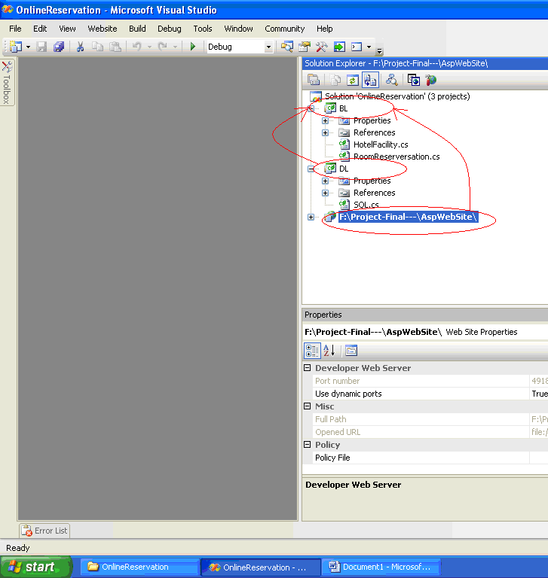
Figure -12-

DL it contains the database connection string.
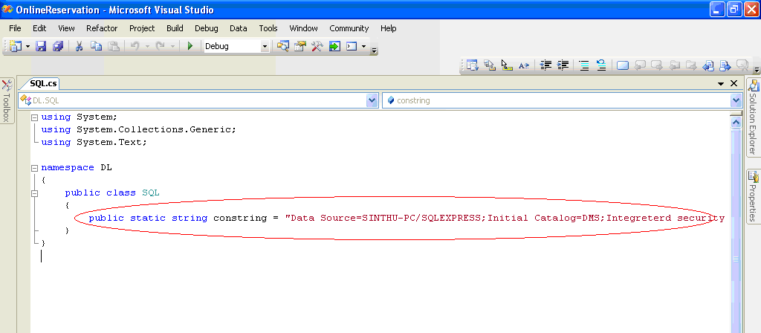

Figure -13-

BL it contains the SQL functions.

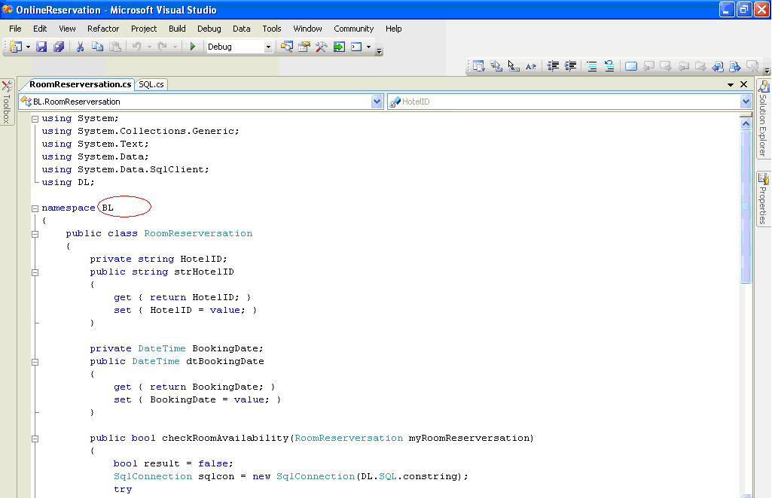

Figure -14-

Through this method if the server changes, no need to change in each and every place.

Testing

After implementing the Destination Management System (DMS) all our group members decided to do below testing for good development. System will tested through Unit-testing, Integration-testing and System-testing. In the System-testing we are going to follow four testing phases, they are Alpha Testing, Beta Testing, Stress Testing and Acceptance Testing.
Different levels of testing and the methods and criteria for performing the test activities will identify. For each level of testing a test plan and the appropriate set of deliverables will prepare. For each test, the following information should be included in the test plan:
- Pre-requisites for the tests.
- Steps required to carry out the tests
- Expected results of the test.
We are going to test the process as below; this is the simple test plan for login process of DMS.
No | Test Case | Test Data | Expected result
1 | Empty Username & empty password | User Name – “” Password – “” | Display the alert message
2 | Invalid username | User Name – “dd” | Display the error message
3 | Invalid password | Password – “aa” | Display Error message
4 | Invalid username & password | User Name–“dd” password – “aa” | Display Error message

Table -1-
After implementing the DMS all our group members will be participating in this phase and our before starting to development actual system a prototype was build.
From this prototype method all our group members can make sure all the requirements are met in the DMS.

Evaluation

Assessment of the Project results
One of the important phases in SDLC is analysis phase. The purpose of the system analysis phase is to understand business requirements and build a logical model of the new system. We identify the problems, its causes, specifying the solution and the information requirements that must be met by the system solution.

Earlier we gathered information via meeting with WTL IT manager and staffs. We interviewed and discussed with them to understand exactly what the client needs. Also we observed the existing systems’ procedures.

Through our analysis phase we identified that WTL facing some problems comparing with other companies in the same industry.

This phase we includes four activities, which are requirements
- Modeling
- Data and process modeling
- Object modeling
- The transition to system design.

Requirements modeling involve investigation and fact-finding to describe the current system and define the requirements for the new system. The data and process modeling involve representation of system data and processes graphically by using a set of diagrams. In object modeling we use object-oriented methods to document, analysis and model the information system. The transition to system design includes evaluation of alternative solution, preparation of the system requirements document and presentation of the system requirements document to management.

THE OVERALL OBJECTIVE OF THE SYSTEMS ANALYSIS PHASE
- To understand the project/system
- To ensure that the project will support the business requirements
- To build a solid foundation for systems design.

We observed that, now WTL is providing only packaged wised services to tourist who reserved a tour through our client WTL. That is tourist can select a tour what already assigned in the WTL, tourist can’t select tour according to their own places. But at the same time some other companies in the same industry are providing open selecting system for tourist. That is tourist can go through their website, and can select the wanted places for their tour and also other needs by clicking.

So now our client WTL also expecting system like mentioned above. In non Package wise method tourist can select the places where they like to visit, after their selection our system is going to calculate the amount for their selected places according to the mileage.
Mileage calculation is very important feature in our system. Also tourist can select their other needs such as food type, room type, vehicle type, guide service. This time also our system is going to calculate the amount for tourist selection. And going show the amount for their all selection for a tour. If tourist satisfied with that much amount they can register for his selection, and can pay through online payment facility in our system. If tourist not satisfied with the amount tourist can go back and select their needs.

This is the main function of our DMS. Our system is also going to send reminders as a mail. Also our standalone system is going to improve the internal user’s works.

THE END PRODUCT OF SYSTEMS ANALYSIS PHASE
- The comprehensive System Requirements document
- The end-product

Lessons Learned
In our developing phase of our system we go through the six main developing phases and in each and very phase we learned so many lessons.

- Feasibility study – we learned how we analysis the problems of the system.

- Requirement Analysis – we learned how we can gather the requirements from the client.

- Design – we learned how we use the object oriented techniques in our system using diagrams.

- Implementation – we learned how to connect the database with system in a easy method.

- Testing – we learned how to find the errors in our system modules through testing methods.

- Maintenance – we learned how to maintain the system.

Future Work
Our suggestions to this system are

- By sending the SMS client can cancel the reservation. (adding SMS function)

- Through the SMS service reminders, can send to client.

- Developing the drag and drop shopping cart method to client reservation.

Conclusion

As described throughout this document the main purpose of implementing the ‘DMS’ is to provide our client with a good, accurate and efficient solution. Hence our main and biggest objective was to come up with a complete computerized, automated system which would replace the existing manual system right now. This system was designed so as to fulfill all the requirements of WTL. The business process was not altered to a greater extent when the system was converted from manual to computerize but certain alterations were done to the new system in order to enhance efficiency and increase productivity.

The first step in starting the project work was the ‘information Gathering Phase’. About 30% of the total system development time (nearly 5weeks) was spent on this phase. Information gathering was done with great care as we were aware that misunderstanding of client requirements would lead to a complete unsuccessful result.
We broke down the whole process into smaller sub systems such as client on-line reservation, Admistrater part, and Marketing officer part so that it would be much easier for us to gather even the smallest and unnoticeable requirement.
After the gathering of requirements the next step was to analyze the gathered requirements. Analysis of the gathered requirements was also done with a lot of care and we paid a lot of attention in bringing out the requirements. After a complete analysis of all the gathered requirements we then moved to the design phase.
Finally we moved to the implementation phase after completion of the design phase.

Below mentioned are some of the general objectives our implemented system provides.
- As their wish Client can easily get register to visit SriLanka.
- Keep track of the Client after they returned from SriLanka.
- Enable the client to obtain the total bill according to their selections.
- Provide mechanisms to update current events or celebrations in SriLanka to the client.
- Ease the workload on the WTL internal people.
- Provides accurate and efficient reports to the Marketing Officer.
- Minimizes the sever loss incurred to the company due to misuse of resources.

The implemented system provides solutions to the heavy problem domain that WTL was facing.
The implementation of the system has made for our client to get register easily and also we are definite that our system would provide correct and reliable information provided that the correct data is fed into the system.
We are also planning to upgrade the system at regular intervals so as to provide the maintenance facility for WTL.

References

[1] Hughes, B. & Cotterell, M.; 2001; Software Project Management; 2nd Edition; New Delhi: Tata McGraw-Hill Publishing Company Limited

[2] Louis, J.Goodman; 1996/ 2001; Project Planning & Management; First Ed; New Delhi; CBS Publishers & Distributors.

[3] Effective Project Management for Web Geeks [online] (updated13th June), p.01-02, Available at: - http://www.sitepoint.com/article/project-management-web-geeks [accessed 8th July 2008]

[4] Ritchie M, 2002 Background, Objectives, Benefits, Scope, Deliverables, Assumptions and Constraints, Estimates. Cost project proposal document of, Corporate Application Technology – Configuration Management [online] (updated 8th Jan), Document. Available at: -http://www.projects.ed.ac.uk/planning/Corporate_IT/2002-03Planning/mis/CorpInf/SoftwareConfigurationManagement.doc [accessed 6th July 2008]

[5] Data Management Subsystem Database Design and Database Schema Specifications for the ECS project, March 199, EOSDIS Core System Project.(pgs 20-45)

[6]Software Requirement Specification Template (Updated 21/09/2008) Available at: http://www. .processimpact.com (Accessed 10/10/2008)

Appendix A: Design Diagrams

Activity Diagrams for DMS
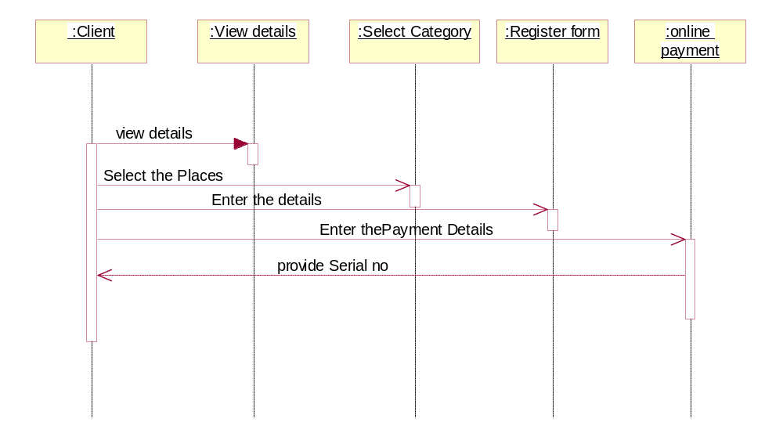

Figure -15- Client reservation

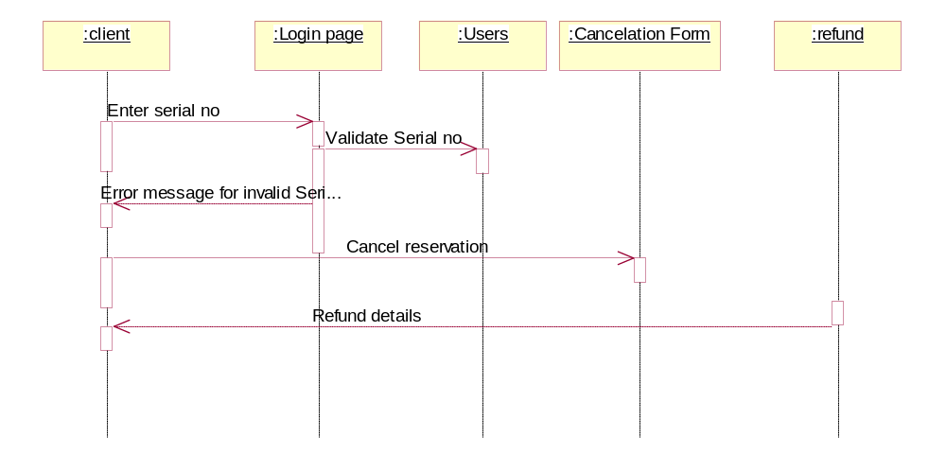

Figure -16- Cancel reservation

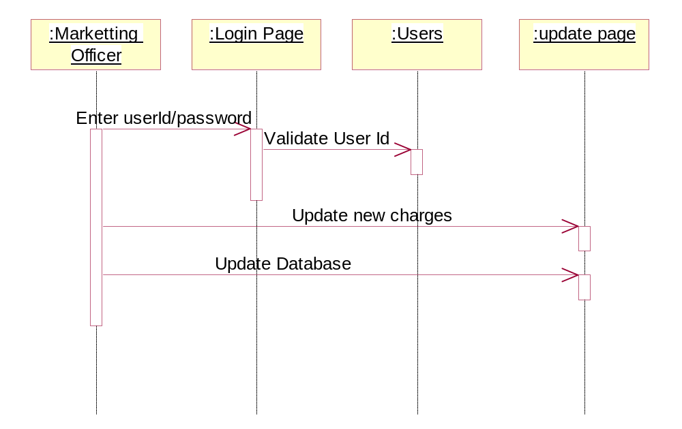
Figure -17- Update new charges

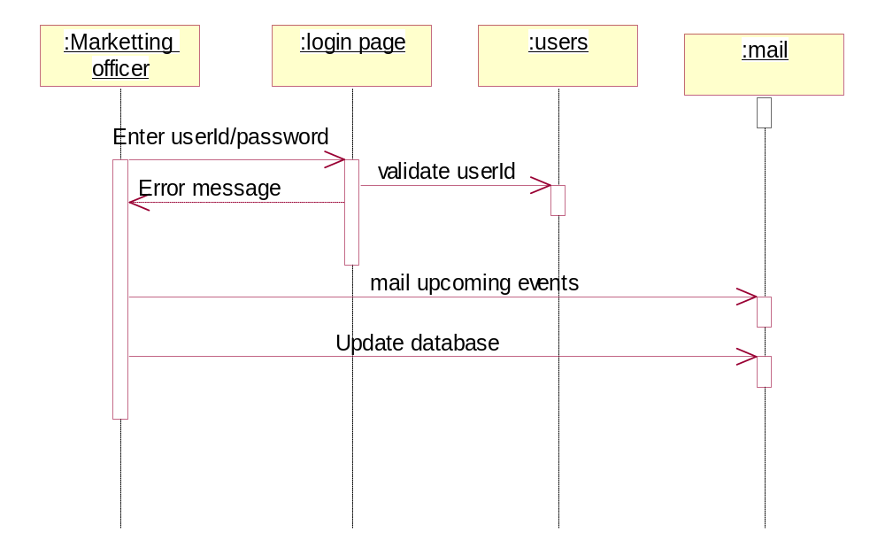

Figure -18- Mail Upcoming Events

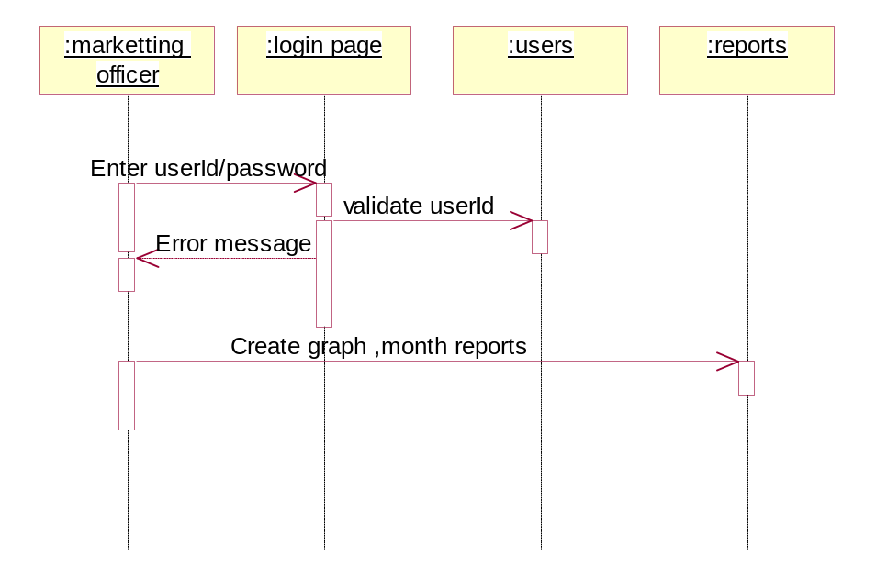

Figure -19- Create Reports

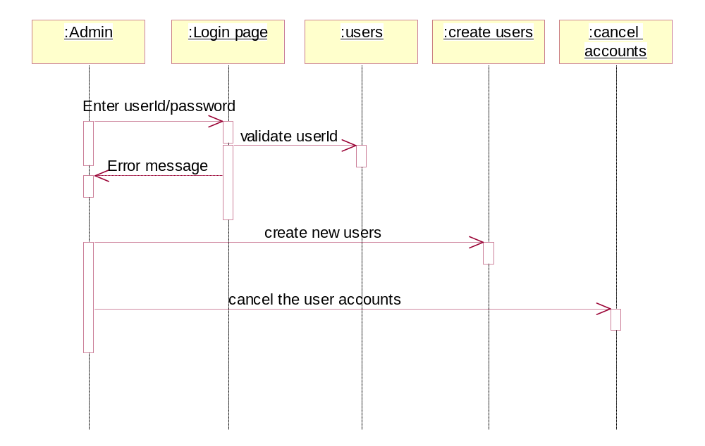
Figure -20 -Administrator Functions

Combining of Deployment diagram and Component diagram

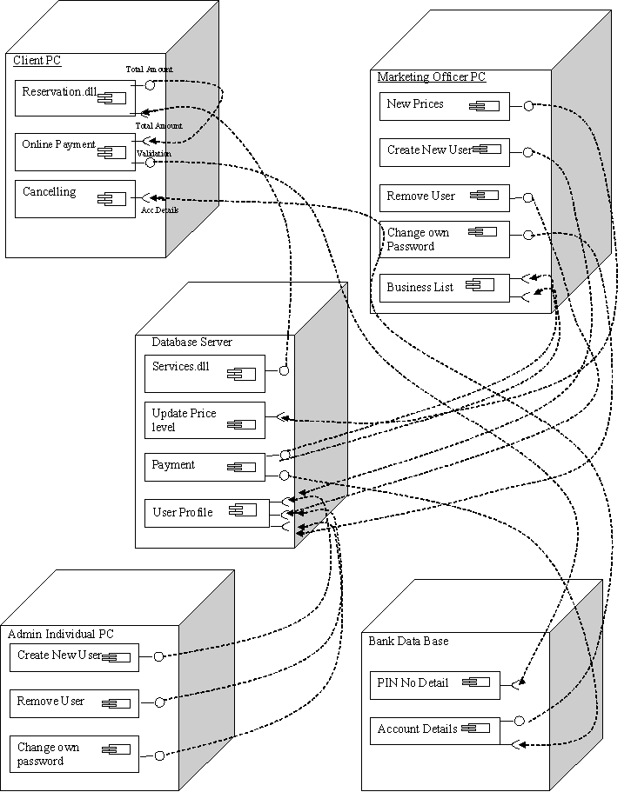

Figure -21 –

Appendix B: Test Results

Our standalones’ login (front) page.

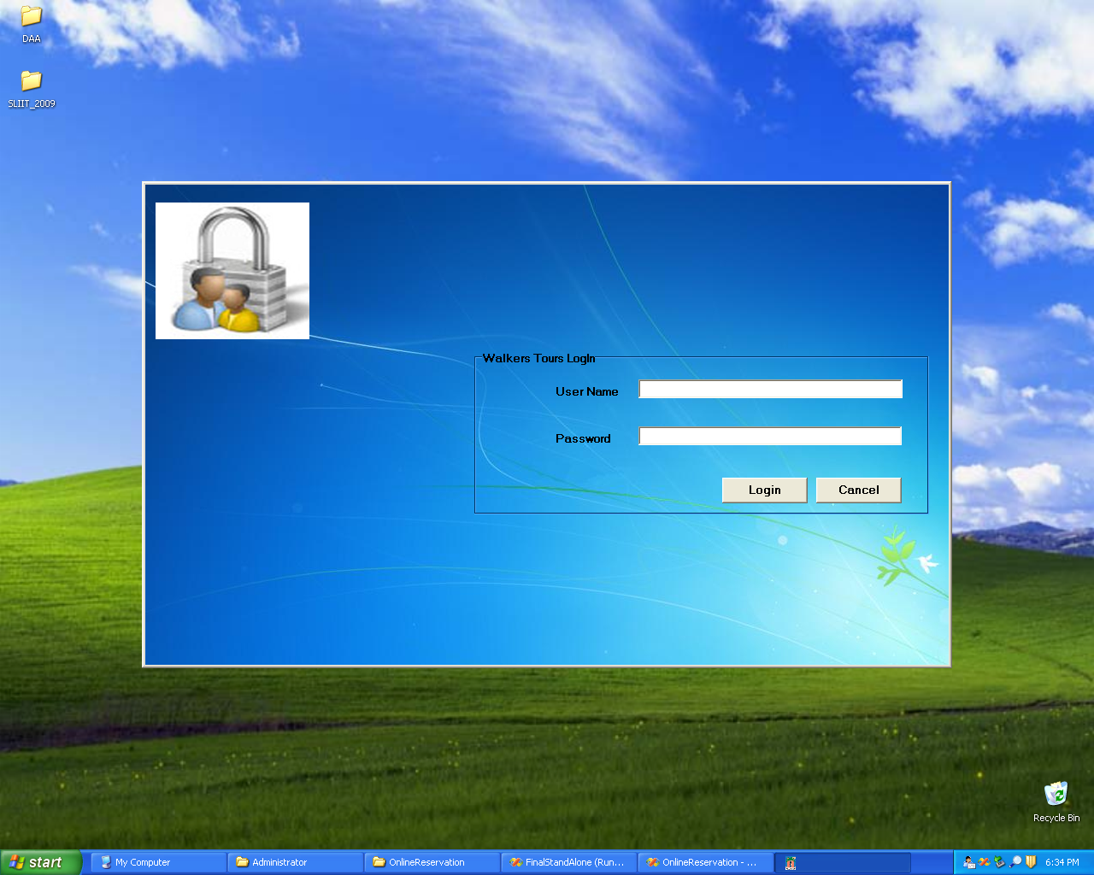

Figure -22 –

Our home page

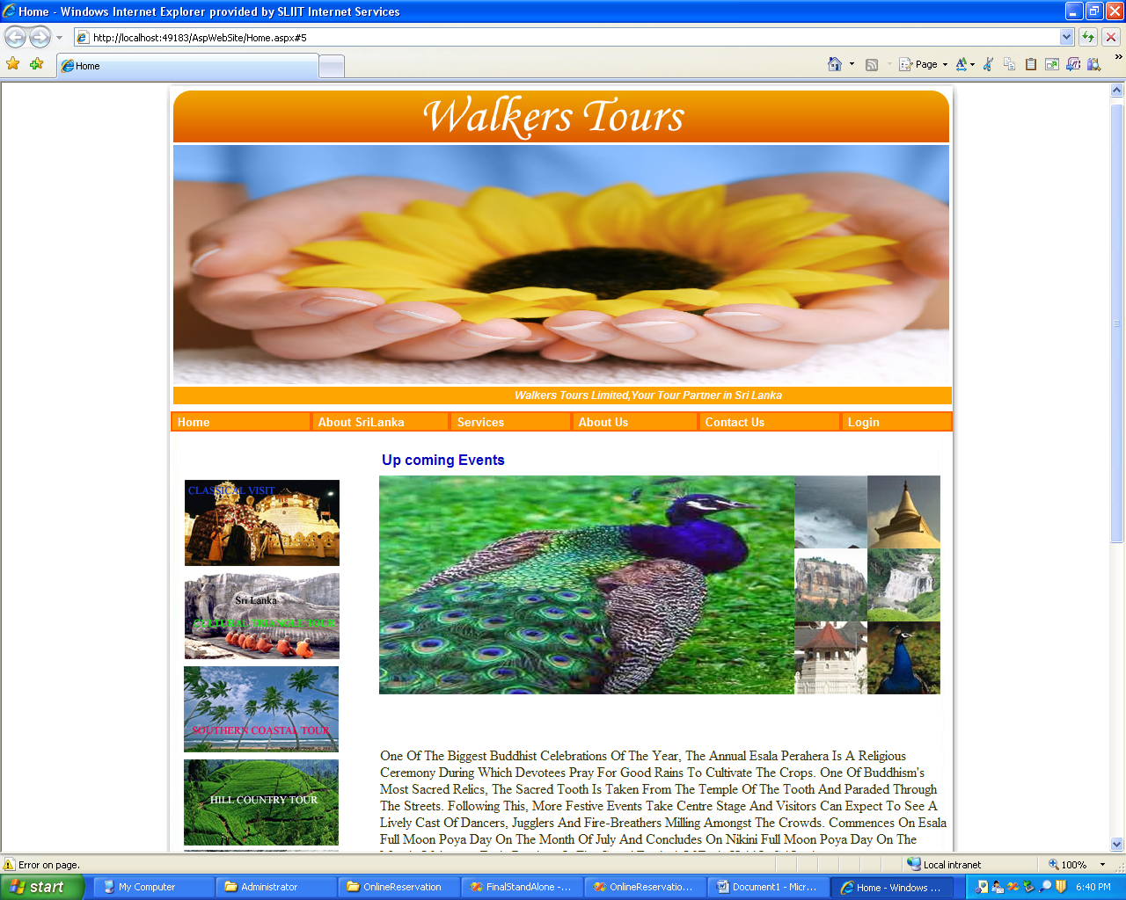

Figure -23 –

Appendix C: Selected Code Listings
We used this below code in our database connection. In here if we change the server we don’t need to modify that in each and every code. We can change the modification in only one place using this code.

Figure -24 –

